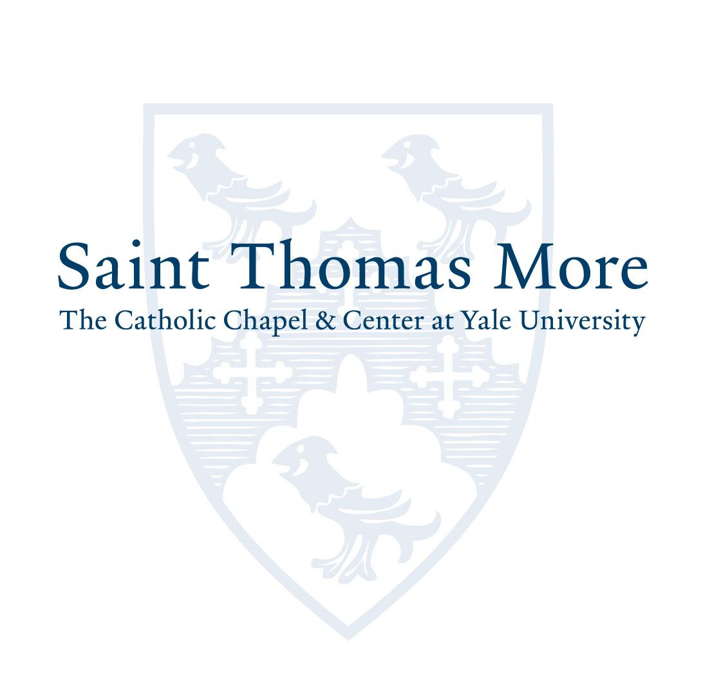

Position: Assistant Chaplain

Focusing on the areas of Study, Pray and Act, Saint Thomas More Catholic Chapel & Center at Yale University (STM) fosters intellectual growth, a rich sacramental life and faith formation opportunities. This is enhanced through social events and both local and international service/immersion experiences. As a campus ministry, STM accompanies students as they navigate their maturation as Catholics at a private ivy-league university, and upon graduation prepares them to be leaders in Church and society.
A vibrant and welcoming community, STM includes ministry to Yale graduate and undergraduate students, faculty and staff, and members of the wider community, including intentional ministry to students with manifold expressions of diversity. Student leaders assist in planning and developing programs that incorporate every aspect of Catholic life.
Focus Area: Undergraduate Ministry
Mission Statement: Saint Thomas More, The Catholic Chapel and Center at Yale (STM): Helping Catholics serve God and humanity locally and globally.
Position Overview: The Assistant Chaplain accompanies undergraduate students in deepening their faith, expanding their involvement in ministry and developing their capacity for service and leadership following their graduation from Yale through student outreach, communication, pastoral care, and evangelization.
Essential Duties and Responsibilities:
- Support the mission of STM
- Develop, implement and evaluate the impact of programs, with an aim at increasing our impact within the Yale Community.
- Participate in the implementation of liturgical and programmatic initiatives according to the STM imperatives Study/Pray/Act, specifically for undergraduate students, in collaboration with the
Chaplain and Assistant Chaplains, including:
  - Faith Formation
  - Liturgy and Sacraments
  - Vocation Awareness
  - Service and Social Justice
  - Leadership Development
  - Retreats
  - Fellowship and Social Opportunities
  - Educational events, such as lectures, reading & discussion groups
- Participate in Leadership, Staff and Committee meetings
- Interface with STM Board Members and prepare Board reports as requested.
- Provide leadership for focus areas as assigned by the Chaplain
- Appoint and work with student leaders to develop and implement student-led programming
- Assist STM in maintaining and fostering relationships with affiliated Yale organizations, such as Yale Religious Ministries and residential colleges, and local community partners
- Other duties as assigned by the Chaplain or designee

Required Qualifications and Skills:
- The Assistant Chaplain must
- Be a practicing Catholic
- Possess strong organizational and time management skills to effectively prioritize multiple tasks.
- Be a self-starter with the ability to work independently with minimal supervision and collaboratively within a team environment.
- Master's degree in theology or related field
- 3-4 years’ experience in campus ministry is preferred
- Ability to work with university students as a positive mentor and role model as well as collaborate with the wider Yale Community
- Solid understanding of faith development and the spiritual needs of university students
- Demonstrates leadership skills including program development, networking, and communication
- Proficiency in social media and other effective ways to communicate with university students
- Fluency in Microsoft Office Suites, Google Suite, Zoom, Canva and other software is necessary
- Must demonstrate strong interpersonal and verbal communication skills with the ability to work with a wide range of constituencies in a diverse community
- Diverse candidates and those with bi-lingual skills are encouraged to apply
Working Conditions
- Be willing and able to work a non-standard work week to include weekends (each Sunday of the academic year), holidays and evening hours
- The Candidate must have a valid driver’s license to transport students to off-campus activities.
- Yale is a large urban campus, which may require the candidate to walk long distances.
- The employee will have an office environment with a quiet to moderate noise level, as well as serving in liturgy with music and events that may include loud noises.
- The employee is frequently required to stand, walk, reach with arms and/or hands and lift to 25 pounds.
STM is an Equal Opportunity Employer
Applications will be accepted online at: https://stm.yale.edu/assistant-chaplain-position through April 12, 2024.

